**ML Project Using Flask**

# Movie Recommender system Project

[**https://www.youtube.com/playlist?list=PLA0J2h1KIAR7xoDbI1usGLVRW6_6qiLuq**](https://www.youtube.com/playlist?list=PLA0J2h1KIAR7xoDbI1usGLVRW6_6qiLuq)

**33 to 39**

1. **Content Based Recommender System with Heroku Deployment**

There are several types of recommendation systems in machine learning, including:

* 1. **Content-based filtering:** Recommends items based on their similarity to items the user has previously liked.
  2. **Collaborative filtering:** Recommends items based on the preferences of similar users.
  3. **Hybrid**: combines both content-based and collaborative filtering to make recommendations.

1. **2nd Video**

**Flow of ML Project**

1. Data Collection
2. Data Preprocessing
3. Model Training
4. Website
5. Deployment

**Import Libraries**

1. **3rd Video**

Stemming in machine learning (ML) refers to the process of reducing a word to its base or root form. The goal is to strip off prefixes, suffixes, and sometimes infixes to simplify the word and normalize variations. For example, "running," "runner," and "ran" could all be reduced to the stem "run."

### Why Stemming is Important

Stemming is commonly used in natural language processing (NLP) tasks such as text classification, sentiment analysis, and information retrieval. By reducing words to their root form, stemming helps in:

1. **Reducing Vocabulary Size**: It reduces the number of distinct words in the text, which simplifies the model and reduces computational complexity.
2. **Improving Search and Matching**: In search engines or document retrieval systems, stemming helps match different forms of a word. For example, searching for "connect" can also retrieve documents containing "connected," "connecting," etc.
3. **Text Normalization**: Stemming helps in standardizing words so that variations are treated as the same, which improves the performance of algorithms that depend on word frequencies.

### Types of Stemming Algorithms

1. **Porter Stemmer**: One of the most common and widely used stemming algorithms, known for its simplicity and effectiveness. It uses a series of rules to iteratively strip suffixes.
2. **Snowball Stemmer**: An improvement on the Porter stemmer, it provides better results for some languages and is more aggressive in stemming.
3. **Lancaster Stemmer**: A more aggressive stemmer compared to the Porter and Snowball stemmers. It often reduces words to very short roots, which may not always be meaningful.
4. **Regex-based Stemmer**: Custom stemmers can be created using regular expressions for specific use cases where standard stemmers may not perform well.

### Example in Python using NLTK

Here’s how you can perform stemming using the Porter Stemmer in Python with NLTK: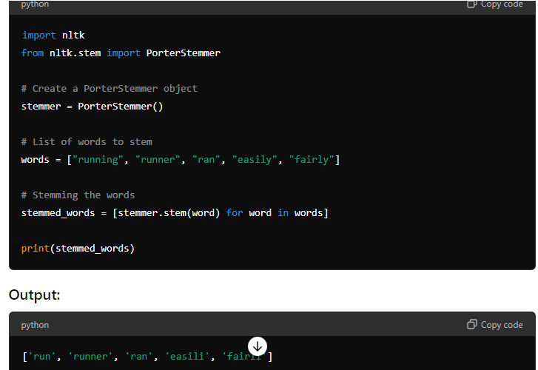

**CountVectorizer:**

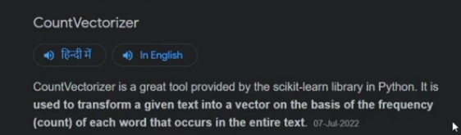

1. **Website designing for machine learning project**

**HTML and CSS Frame work: getbootstrap.com >>** Click on **Docs >>** Copy **Include Bootstrap’s CSS and JS >>**

**Open Tailwind CSS >>** [**https://tailwindcss.com/**](https://tailwindcss.com/) **>>** Click **on Get Started >>** Click on **Play CDN >>**

Copy and paste it to Text Editor **<script src="https://cdn.tailwindcss.com"></script>**

**Open TailBlocks >>** [**https://tailblocks.cc/**](https://tailblocks.cc/) **>>**

Select **Header >>** Click on **View Code >> Copy to Clipboard >>**

Select **Header >>** Click on **View Code >> Copy to Clipboard >>**

Select **Testimonial >>** Click on **View Code >> Copy to Clipboard >>**

Select **Footer >>** Click on **View Code >> Copy to Clipboard >>**

**Open Tailwind CSS Colors >>** [**https://tailwindcss.com/docs/customizing-colors**](https://tailwindcss.com/docs/customizing-colors) **>> This will help to get the color code**

**Open updraw >>** [**https://undraw.co/illustrations**](https://undraw.co/illustrations) **>> search for movies >>**

1. **Website designing for machine learning project**

**Open Flask >>** [**https://flask.palletsprojects.com/en/2.2.x/**](https://flask.palletsprojects.com/en/2.2.x/) **>> Website >> Copy the code and change accordingly**

**Open cmd from path >>** Enter **python app.py >>** Enter **virtualenv moviesenv >> moviesenv\scripts\activate >>pip install flask pandas numpy sklearn >> python app.py >>open the site with like created**

**getbootstrap.com >>** Click on **Docs>> Search for form and button**

1. **Deploy machine learning project using flask**

**Code in app.py**

To take image open **tmdb movies**

**22.14**

**17**

<a href="/"><span class="ml-3 text-xl">Movies Recommendation System</span></a>

<!doctype html>

<html lang="en">

<head>

<meta charset="utf-8">

<meta name="viewport" content="width=device-width, initial-scale=1">

<title>Movie Recomendation System</title>

<script src="https://cdn.tailwindcss.com"></script>

<link href="https://cdn.jsdelivr.net/npm/bootstrap@5.3.3/dist/css/bootstrap.min.css" rel="stylesheet" integrity="sha384-QWTKZyjpPEjISv5WaRU9OFeRpok6YctnYmDr5pNlyT2bRjXh0JMhjY6hW+ALEwIH" crossorigin="anonymous">

</head>

<body class="bg-gray-200">

<header class="text-gray-600 body-font -my-8">

<div class="container mx-auto flex flex-wrap p-5 flex-col md:flex-row items-center">

<a class="flex title-font font-medium items-center text-gray-900 mb-4 md:mb-0">

<svg xmlns="http://www.w3.org/2000/svg" fill="none" stroke="currentColor" stroke-linecap="round" stroke-linejoin="round" stroke-width="2" class="w-10 h-10 text-white p-2 bg-green-500 rounded-full" viewBox="0 0 24 24">

<path d="M12 2L2 7l10 5 10-5-10-5zM2 17l10 5 10-5M2 12l10 5 10-5"></path>

</svg>

<span class="ml-3 text-xl">Movies Recommendation System</span>

</a>

<nav class="md:ml-auto flex flex-wrap items-center text-base justify-center">

<a href="/" class="mr-5 hover:text-gray-900">Home</a>

<a href="/about" class="mr-5 hover:text-gray-900">About</a>

<a href="/contact" class="mr-5 hover:text-gray-900">Contact</a>

<a href="/prediction" class="mr-5 hover:text-gray-900">Prediction</a>

</nav>

</div>

</header>

<section class="text-gray-600 body-font -my-8">

<div class="container px-5 py-24 mx-auto">

<div class="flex flex-col text-center w-full mb-12">

<h1 class="sm:text-3xl text-2xl font-medium title-font mb-4 text-gray-900">Movies Recommendation System</h1>

<p class="lg:w-2/3 mx-auto leading-relaxed text-base">A Movie Recommendation System, is an ML based approach to filtering or predicting the users' film preferences based on their past choices and behavior. It's an advanced filtration mechanism that predicts the possible movie choices of the concerned user and their preferences towards a domain-specific item, aka movie.</p>

</div>

<div class="row">

<div class="col-md-3"></div>

<div class="center col-md-6"></div>

<form action="/prediction" method="POST">

<select class="form-select" id = "movies" name = "movies" aria-label="Default select example">

{% for j in movie_list %}

<option value="{{j}}">{{j}}</option>

{% endfor %}

</select><br>

<button type="submit" class="btn btn-success">Submit</button>

</form>

</div>

</div>

</div>

</section>

{% if status == True %}

<section class="text-gray-600 body-font" style="margin-top: -180px;">

<div class="container px-5 py-24 mx-auto">

<h2 class="sm:text-3xl text-2xl font-medium title-font mb-2 text-gray-900">These are the recommended movies: </h2>

<div class="flex flex-wrap -m-4">

<div class="xl:w-1/4 md:w-1/2 p-3">

<div class="bg-gray-100 p-6 rounded-lg">

<img class="h-40 rounded w-full object-cover object-center mb-6" src="https://dummyimage.com/720x400" alt="content">

<h3 class="tracking-widest text-indigo-500 text-xs font-medium title-font">SUBTITLE</h3>

<h2 class="text-lg text-gray-900 font-medium title-font mb-4">Chichen Itza</h2>

</div>

</div>

<div class="xl:w-1/4 md:w-1/2 p-3">

<div class="bg-gray-100 p-6 rounded-lg">

<img class="h-40 rounded w-full object-cover object-center mb-6" src="https://dummyimage.com/720x400" alt="content">

<h3 class="tracking-widest text-indigo-500 text-xs font-medium title-font">SUBTITLE</h3>

<h2 class="text-lg text-gray-900 font-medium title-font mb-4">Chichen Itza</h2>

</div>

</div>

<div class="xl:w-1/4 md:w-1/2 p-3">

<div class="bg-gray-100 p-6 rounded-lg">

<img class="h-40 rounded w-full object-cover object-center mb-6" src="https://dummyimage.com/720x400" alt="content">

<h3 class="tracking-widest text-indigo-500 text-xs font-medium title-font">SUBTITLE</h3>

<h2 class="text-lg text-gray-900 font-medium title-font mb-4">Chichen Itza</h2>

</div>

</div>

<div class="xl:w-1/4 md:w-1/2 p-3">

<div class="bg-gray-100 p-6 rounded-lg">

<img class="h-40 rounded w-full object-cover object-center mb-6" src="https://dummyimage.com/720x400" alt="content">

<h3 class="tracking-widest text-indigo-500 text-xs font-medium title-font">SUBTITLE</h3>

<h2 class="text-lg text-gray-900 font-medium title-font mb-4">Chichen Itza</h2>

</div>

</div>

</div>

</div>

</section>

{% endif %}

<script src="https://cdn.jsdelivr.net/npm/bootstrap@5.3.3/dist/js/bootstrap.bundle.min.js" integrity="sha384-YvpcrYf0tY3lHB60NNkmXc5s9fDVZLESaAA55NDzOxhy9GkcIdslK1eN7N6jIeHz" crossorigin="anonymous"></script>

</body>

</html>